System Description of PLL-Evalboard-Synthesizer

Rich Rademacher, University of Waterloo/IQC

# Introduction

This document describes our Phase-Locked Loop (PLL) frequency synthesizer for generating medium-precision RF carrier wave (CW) signals. The Quantum Ion Trap group at the Institute for Quantum Computing (IQC) uses a series of evaluation boards from Analog Devices and Peregrine Semiconductor to provide a low-cost series of RF drive signals. Custom boards may be designed later if desired. These signals are calibrated to industry standards, not atomic standards, and so are medium-precision. Analog Devices documentation refers to *both* products as ‘microwave’ synthesizer, but in keeping with AMO community convention we delineate Microwave as >10 GHz, while RF is considered all lower frequency carriers.

# System Design

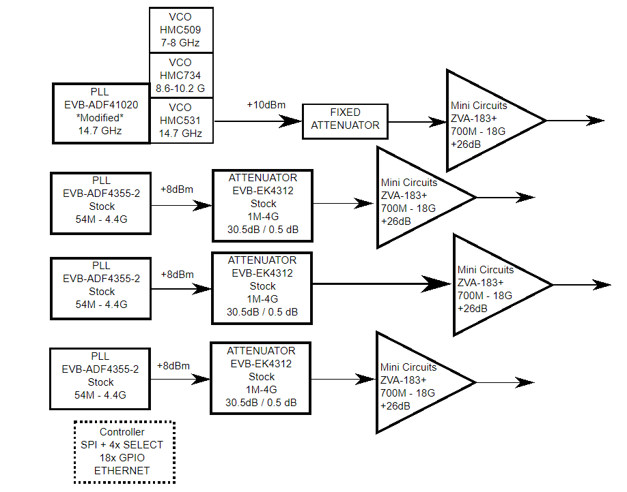

Figure 1 - System Block Diagram

## Oscillator Configuration

The system is designed around a series of Phase-Locked Loop evaluation boards. The ADF-41020 phase locked loop provides microwave carrier, and ADF-4355-2 phase locked loop provides RF carriers. The 4355-2 is wider band, with on-chip voltage-controlled oscillator (VCO). The microwave synthesizer 41020 is narrower band and uses an external VCO. Finally, the ADF4360-8 provides a constant ~200MHz signal which is split to all AOM switches used for quickly turning on or off a beam path. The frequency bandwidth is only around 20 MHz, but the center frequency can be changed by switching two surface mount inductors

## Amplitude Control

The RF system is designed with programmable amplitude control. The Peregrine Semiconductor EVB-EK4312 programmable attenuator is used to drive the input amplitude prior to final gain. The microwave synthesizer is not programmable due to lack of suitable evaluation board.

## Control Processor

The PLL oscillators and attenuators are controlled via a Raspberry Pi 3 control board. The PLL boards are controlled via serial peripheral interface (SPI) bus, while the attenuators are controlled as individual general-purpose I/O (GPIO) pins.

## Final Amplifier

The final drive to the appropriate laser modulator (AOM or EOM) is provided by several different amplifiers. The ZVE-3W-183+ amplifier from mini-circuits is used to amplify the ADF41020 signals. The ZHL-4240W+ amplifier from mini-circuits amplifies the variable RF signals from the ADF4355 PLLs. Finally, the MPA-11-40 amplifier from RF-Bay amplifies the ~200 MHz signals which mostly come from the ADF4360 PLLs.

# Control Software

The Raspberry Pi 3 provides a Python control program to interface with GPIO lines and SPI. Programs have been written for all PLLs and Attenuators in Python. More information is provided elsewhere.